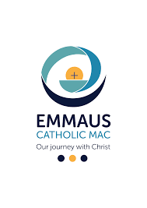

Year 5
Academic Year: 2025-2026

Our Lady Queen of Peace Primary School Class Curriculum Overview

Curriculum Area | Autumn Term 1 |  |  |  | Autumn Term 2 |  |  |  | Spring Term 1 |  |  |  | Spring Term 2 |  | Summer Term 1 |  |  |  | Summer Term 2
Trip/ Enrichment opportunities |  |  |  | Visit to Worcester Museum |  |  |  |  |  |  |  |  |  |  | Forest School |  |  |  | Forest School
Religious Education | Our Class Saint – Carlo Acutis 
Religious Education | Unit A: Creation  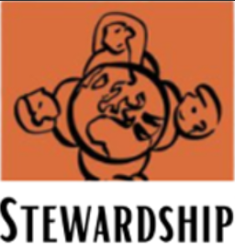  Unit B: Miracles and Sacraments of the Sick   | Unit E : Baptism  Unit C : Advent  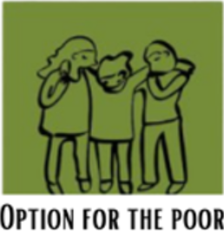 |  |  |  |  |  |  | Unit D: Christmas  Unit F: Parables and sayings of Jesus   |  | Unit G: Lent  Unit H: Holy Week   |  |  |  | Unit I: Easter  Unit J: Pentecost |  | Unit L : Marriage and Holy Orders  Unit K: The workings of the Apostles
Writing | For Writing, transcription and formation are taught using the I Am A Clever Writer approach, which provides a systematic framework for the development of writing skills; progression documents are available internally and used to ensure high expectations and clear next steps in children's learning.
Writing | Retell – The Emperor’s New  Describe setting, characters and atmosphere.  Retell – The Chocolate Tree  Rain Player – Diary entry  Mayan Non-Chronological Report  Retell – Bruce Bogtrotter Eating the Chocolate Cake |  | The Lighthouse – Settings Description / retell  Retell - The Enormous Turnip  Egg Drop – Retell  The True Story of the Three Little Pigs – Diary Entry & Formal Letter of Complaint |  |  |  | Winter Haikus  Retell - The Way Back Home  Retell - Field Trip to the Moon  The Good Samaritan  Biography – Katherine Johnson |  |  |  |  |  |  | Non-chronological Report – Earth and Space  Retell – Idia and the Benin Kingdom.  Tadpole’s Promise - Setting Description & retell & letter |  | Broken: Rock, Paper, Scissors -Retell & Character Description  Queen Victoria’s Bathing Machine – Informal letter  Life Cycle Explanation |  |  |  | Monsoon – Diary Entry  Star bird – setting description  Biography – Jane Goodall  A poem to be spoken silently
Reading |   Escape Room by Christopher Edge  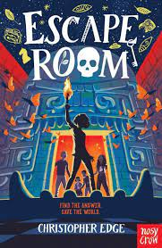 |  |  |  |  | Rain Player by David Wisniewski  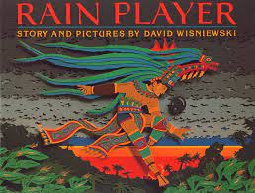 |  | The Kid who came from Space by Ross Welford  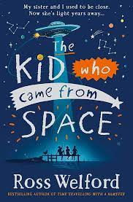 |  | The skies Above my Eyes by Charlotte Guillain  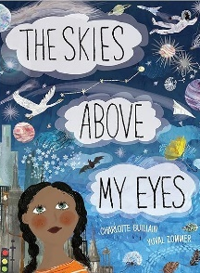 |  |  |  |  | The Explorer by Katherine Rundell  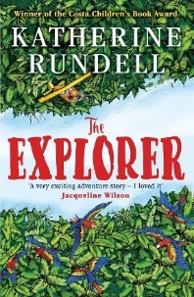 |  |  |  | Non-fiction texts based on the British Empire/Inside India  
Maths | Learning is carefully sequenced according to the White Rose Hub: Progression of Learning guidance, ensuring consistency and progression across year groups.
Maths | Number – Place Value  Number – Addition and Subtraction  Number – Multiplication and Division A  Number – Fractions A |  |  |  |  |  |  |  | Number – Multiplication and Division B.  Number – Fractions B.  Number – Decimals and percentages  Measurement – Perimeter and Area  Statistics |  |  |  |  |  | Geometry – Properties of Shape  Geometry – Position and Direction  Number – Decimals  Number – Negative numbers  Measurement – Converting Units  .Measurement – Volume
Science | Autumn Term scientist:  Stepanie Kwolek  Properties and changes of Materials |  |  |  | Forces |  |  |  | Spring Term scientist:  Nicolaus Copernicus  Earth and Space |  |  | Living Things & Their Habitats |  |  | Summer Term scientist: Jane Goodall  Living Things & Their Habitats   |  |  | Animals (including humans)
Geography |  |  |  |  |   Mesoamerica / Central America  Where did the Mayans live and what was it like there, then and now |  |  |  |  |  |  | Benin  Where is Benin and how has it changed over time? |  |  |  |  |  | Inside India  What is life like in India  
History | The Mayans  How does the Mayan civilisation compare to British History? |  |  |  |  |  |  |  | The Tudors  (1485 – 1603)  What made the Tudors so powerful |  |  |  |  |  | British Empire including Queen Victoria ( 1500s- 1900s)
Music | Charanga Music:  Livin’ On A Prayer |  |  | Charanga Music:  Classroom Jazz 1 |  |  |  |  | Ukulele |  |  |  |  |  | Dancing in the Street  Motown |  |  | Fresh Prince of Bel Air  Hip hop
Art | Drawing: Portraits |  |  |  |  |  |  |  | Drawing: I need space |  |  |  |  |  | Craft and design: Architecture
Design and Technology |  |  |  |  | Mechanical systems:  Pop up book |  |  |  |  |  |  |  | Textiles: Stuffed toys |  |  |  |  |  | Structure: Bridges
PE 1 | Gymnastics |  |  | Fitness |  |  |  |  | Swimming |  |  |  |  |  | Cricket |  |  | Volleyball
PE 2 | Netball |  |  |  | Hockey |  |  |  | Dance |  |  |  | Yoga |  | Athletics |  |  |  | Rounders
COMPUTING | Computer Systems and networks - |  |  |  | Programming 1 |  |  |  | Creating Media |  |  |  | Programming 2 |  | Data and Information |  |  |  | Creating Media
PSHE/RSE | TEAM    (Relationships) |  |  |  | Think positive  (Health and Wellbeing) |  |  |  | Diverse Britain  (Living in the Wider World) |  |  |  | Be Yourself  (Relationships) |  | It’s my body  RSE – A Journey in love  (Health and Wellbeing)  (Health and Wellbeing |  |  |  | Aiming High  (Living in the Wider World)
MFL - French | That’s Tasty! |  |  |  |  |  |  |  | School Life |  |  |  |  |  | Time Travelling

